CHRISTIANS TOGETHER FOR CREATION
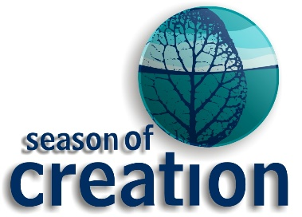
A CELEBRATION OF PRAISE
AND THANKSGIVING
‘Let justice roll on like a river, righteousness like a never-failing stream!’ Amos 5.24

SUNDAY 16TH SEPTEMBER 2018 4.30-5.30 pm (refreshments from 4pm)
WESLEY CHAPEL Oxford Street Harrogate HG1 1PP
Contact : harrogatect@gmail.com, www.ctharrogate.org.uk

