To Churches Together…
NEWSLETTER
EASTER 2018
Dear Friends
Easter Greetings from West Yorkshire Churches Together

Can we be United?
The Archbishop of Canterbury recently addressed the World
Council of Churches, marking its 70th Anniversary. Is work for
Christian Unity still in a "winter"? Archbishop Justin sees a "springtime". We should not overlook the co-operation and contacts that are now so much a feature of churches in local areas. In my view, when we refer to unity, we are not talking about a complete uniformity of belief with every i dotted and t crossed. We are simply talking of Christians sharing a communion, a unity in Christ.
He talked of "Open Borders" that is to say that we are one- with differences – rather than we are many seeking what it is to be one. "To see ourselves as one with fractures is vastly more authentic to the work and purpose of God in Christ through creation, through salvation history, through the work of the spirit today and towards the revealing of the kingdom of God, than it is to see ourselves as different, as other."
"As I have said before, the way we live is like a family where the relationships have broken down. They may live in the same house, but they live in separate rooms, they have separate lives and they do not talk to each other, politely, too easily./
/We become to used to it. We begin to think, “This is normal.” It is not normal. It is deceiving. We are deceived and we deceive the world into the purpose and power of Christ."
There is more in the full address which you can find on our website. It is well worth reading or studying together. Nick Shields, Administrator WYCT
About us: WEST YORKSHIRE CHURCHES TOGETHER is the county ecumenical body for West Yorkshire- the county and those parts which are covered by West Yorkshire Dioceses and Districts. Our website is at westyorkshirechurchestogether.com And our e-mail: westyorkshirect@icloud.com
WYCT was one year old on 1st January. We held our AGM in March. We reviewed the progress that has been made in organising our Local Ecumenical Projects (LEP’s) where DEO Convenor Glenn Coggins has done a lot of work in bringing the proposals for simplification from Churches Together in England into a workable shape. In future formation and review will be less complicated!
The "Forum" is the old Council of Church Leaders (WYEC) which, is now part of WYCT. It meets three times a year, one meeting being residential. Since it began, our Convenor or Chair has been Michael Highton of the Salvation Army. Each Convenor serves for a year.
Tony Robinson, Bishop of Wakefield, has been elected chair for 2018/19.
The Deputy Convenor is Bishop Tony Parry of the New Testament Church of God.
CTE:
Churches Together in England (CTE) has in the meantime made a new appointment:
The Revd Dr Paul Goodliff has been appointed General Secretary.
He will take up his appointment in September following the retirement of Revd Dr David Cornick, who says, ‘It is very good news indeed that the leadership of CTE will be in such capable hands as the churches of England build on their excellent relationships and reflect on ways in which they can collaborate in mission together.’
Paul is presently co-minister of Abingdon Baptist Church, having served previously as General Superintendent of the Baptist Union’s Central Area, and then as the Baptist Union’s Head of Ministry. He is well known as a lecturer and is the author of books on pastoral care, the theology and psychology of shame, and most recently, a study of ministerial formation and virtue ethics, Shaped for Service (2017). Widely experienced ecumenically, Paul has been a member of the WCC-Pentecostal Joint Consultative Group since 2000.

Theos Report on CTE
CTE’s Board took the decision last year to fund research by the thinktank Theos into the current state of ecumenism in England. They hope that the report will be widely read and discussed, and that it will help our member churches to consider how they wish to work together in mission over the next five to ten years. This identified CTE’s strengths as including:
- CTE plays a vital role in developing and brokering relationships between Churches, particularly at the national level and provides a space for open conversations
- With 44 member Churches, CTE reflects the diversity of
Christianity in England
- CTE has the potential to amplify the voice of smaller Churches who wish to speak on issues which concern them.
It also pointed to weaknesses:
- Lack of clear vision and purpose: what is CTE for? What is the relationship/duplication/difference between CTE and CTBI?
- Lack of visibility and public profile
- Difficulties around ‘speaking with one voice’: on what issues?
- How can CTE best 'get the word out’?
These are recognisable problems for all of us too: how can CT’s demonstrate a vision of unity and help the churches/leaders here to speak with one voice?
53% of those questioned by THEOS saw work for Unity increasingly
"focused on the local level, low-key, and institutionally nimble" This seems correct- in other words the work of CT’s!

YOUR DATA
We are also anxious to build up the network of Churches Together: and the fact that you are reading this means that you are part of it. If you see yourselves as part of Churches Together in England (CTE) then WYCT is your regional "Intermediate Body". But…If you are receiving this and don’t know why- please let us know. If you are receiving this and someone else is the contact person- please let us know. We can add extra names if other people want to receive this themselves- no problem.
We have not tracked down all the e-mail details for West Yorkshire
CT’s, but I have changed addresses for any that have "bounced." New legislation on Data Protection means that I shall have to contact all of you using personal e-mail addresses, to obtain consent to continue send these newsletters. It will advise you of the purpose of the data storage (contact with WYCT) and its security.

NEWS
for
The Methodist District Spring Newsletter -click HERE- The latest Leeds Anglican Diocese Newsletter-click HERE

YOUR KINGDOM COME- from Easter to Pentecost
This proved to be a very popular initiative last year and it is being repeated in 2018.
A beacon event is a PENTECOST PARTY on Pentecost Sunday 20th May from 1:30-5:30 at the John Charles Centre, LEEDS LS11 5DJ With Worship led by Stuart Townend and Preacher Jill Baker: Bouncy Castles- live music- choirs- picnic area- face painting and entertainers!
Free tickets from Eventbrite https://www.eventbrite.co.uk/e/ yorkshire-west-methodist-district-pentecost-party-an-event-for-allages-tickets-44218599020

WCC
It’s 70 years since the World Council of
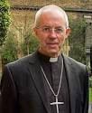
Churches was founded in Amsterdam on 23
August (see report above on Archbishop of Canterbury’s address), In addition to a commemoration service in Amsterdam on 23 August, the WCC, its member churches and partners are planning a variety of events to move forward -click this link: http:// www.oikoumene.org/en/wcc70/

OTLEY CHEVIN CROSS - 50TH ANNIVERSARY
Despite the Arctic weather the Chevin Cross was hoisted into place for this 50th Anniversary appearance. Since its inception in 1968 the Chevin Cross has had a profound impact reaching far beyond the seven churches, of the ‘Otley Council of Christian Churches’, who were involved in its creation and erection. Its influence has reached out into the world beyond Wharfedale to give hope and peace to many people.
The Cross was originally the idea of a local Methodist Lay
Preacher and Funeral Director D. B. Good who came back from
Austria after seeing hillside crosses there. It was discussed by the Otley Council of Christian Churches and a permanent cross was considered but rejected as it was felt that by familiarity it could eventually lose some of its impact. The cross requires over fifty people to hoist it into position and this annual demonstration is a sign that unity is important and churches need to work together as Christ commanded us.
At various times vandals have tried to burn the Cross and it was once cut-down with a chainsaw. But these attempts to sabotage the Christian symbol were more than compensated for by church and non-churchgoers alike
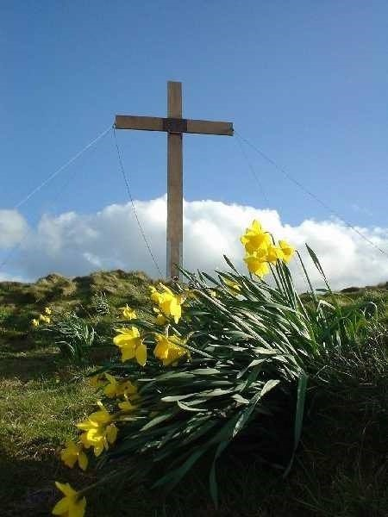
The original cross was replaced for the Millennium in 2000 using timber which came from the Arndale Centre in Manchester which had been bombed by the
IRA in a terrorist attack in 1996. It is a reminder that good will triumph over evil as Christ rose from the dead.
THE POWER OF THE

CROSS
Fifty years after the first cross was conceived what are the lessons to be learned? Well it has proved that prayer works! Within hours of it being erected for the 50th Anniversary nearly 800 people went on Facebook to welcome its arrival. The annual Sunrise Service held at 7am on Easter Sunday morning regularly attracts some 300 people to respond to the age-old greeting
“Christ is Risen” by responding “He is risen Indeed.”
A booklet “The Chevin Cross – Otley 1968-2018” is now available giving full details and comments on the Cross’s history and
impact. (We will forward any enquiries) Ron Sweeney, Churches Together in Otley

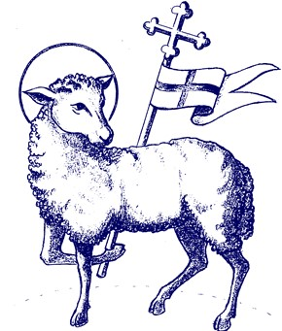
How are we Shaping the
Future of our Planet?

Saturday 28th April 2018

£21.00

including lunch and refreshments)
(

am
10.00
-
pm
3.30

To book or for more details, contact:

Beth Harper,
The Mirfield Centre, Stocks Bank Road, Mirfield, WF14 0BW

Tel: 01924 481920 e
-
mail: bharper@mirfield.org.uk www.mirfield.org.uk

Director: Revd Canon June Lawson

Administrator: Beth Harper

MIRFIELD CENTRE

The day will have four presentations on Climate Change, Care
of the Earth, Lifestyle and Love for the Poor. Each presentation
will be followed by question and discussion time.

Led by Ellen Teague

London
-
based freelance Catholic journalist who writes
and campaigns on Justice, Peace and Ecology issues.

In partnership with Christians Aware

Student Christian Movement is recruiting..
SCM currently has two vacancies for our staff team, one based in Birmingham and one based in the North East/Yorkshire: SCM is seeking to employ a Regional Development Worker for the North East and Yorkshire, who will also be the lead Project Worker for our Faith in Action Project. This is a full time post, with a salary of £20-22,000 depending on experience.
SCM also has a vacancy for an Administration Assistant to start as soon as possible, based in Birmingham. The post is part time (14 hours per week), with a salary of £15-17,000 pro rata depending on experience.
The closing date for applications for both posts is 12 noon on
Monday 16th April. Interviews will take place the week beginning 23rd April. Much more information, including details of how to apply, can be found at www.movement.org.uk/jobs
The Blackley Centre: In July 2017 Blackley Baptist Church decided to embark on a new chapter to develop the Blackley Centre as a place for peace making and inter faith relations, under the guidance of new joint Directors. It is developing work in peace making and inter faith relations to help churches and others deal positively with conflict and build good relations with people and communities of other faiths. The Centre is very near junction 24 of the M62, between Huddersfield and Halifax.. Further details can be found on www.blackleycentre.co.uk and there is a …
Coming Event…
Relating to Sikhs and Sikhism
Saturday 21st April 2018, 10am to 4pm
An introductory day for Christians, church groups and people of all faiths and none- see the website as above… LINKS OF INTEREST:

JPIT YORKSHIRE
The Joint Public Issues Team (JPIT) Yorkshire brings a Christian voice and vision to public issues that affect the people of
Yorkshire -environment, social justice, politics
It is the northern offshoot of national JPIT and is sponsored by the regional bodies of the Baptist, Methodist and United Reformed churches. You can find more on https://jointpublicissuesyorkshire.org.uk

LEEDS J&P
The long established Leeds Catholic Justice and Peace Group has a regular newsletter on these issues; March’s can be viewed here

NETWORK LEEDS
is a website and e-mail subscription which carries latest news, events, jobs and volunteering opportunities from across the Christian communities of Leeds https://networkleeds.com/news

Thanks for all you do for unity…
Let Christ, the true light and morning star, shine in our hearts,
He who gives light to all creation,
Who lives and reigns with You and the Holy Spirit, One God, now and forever.
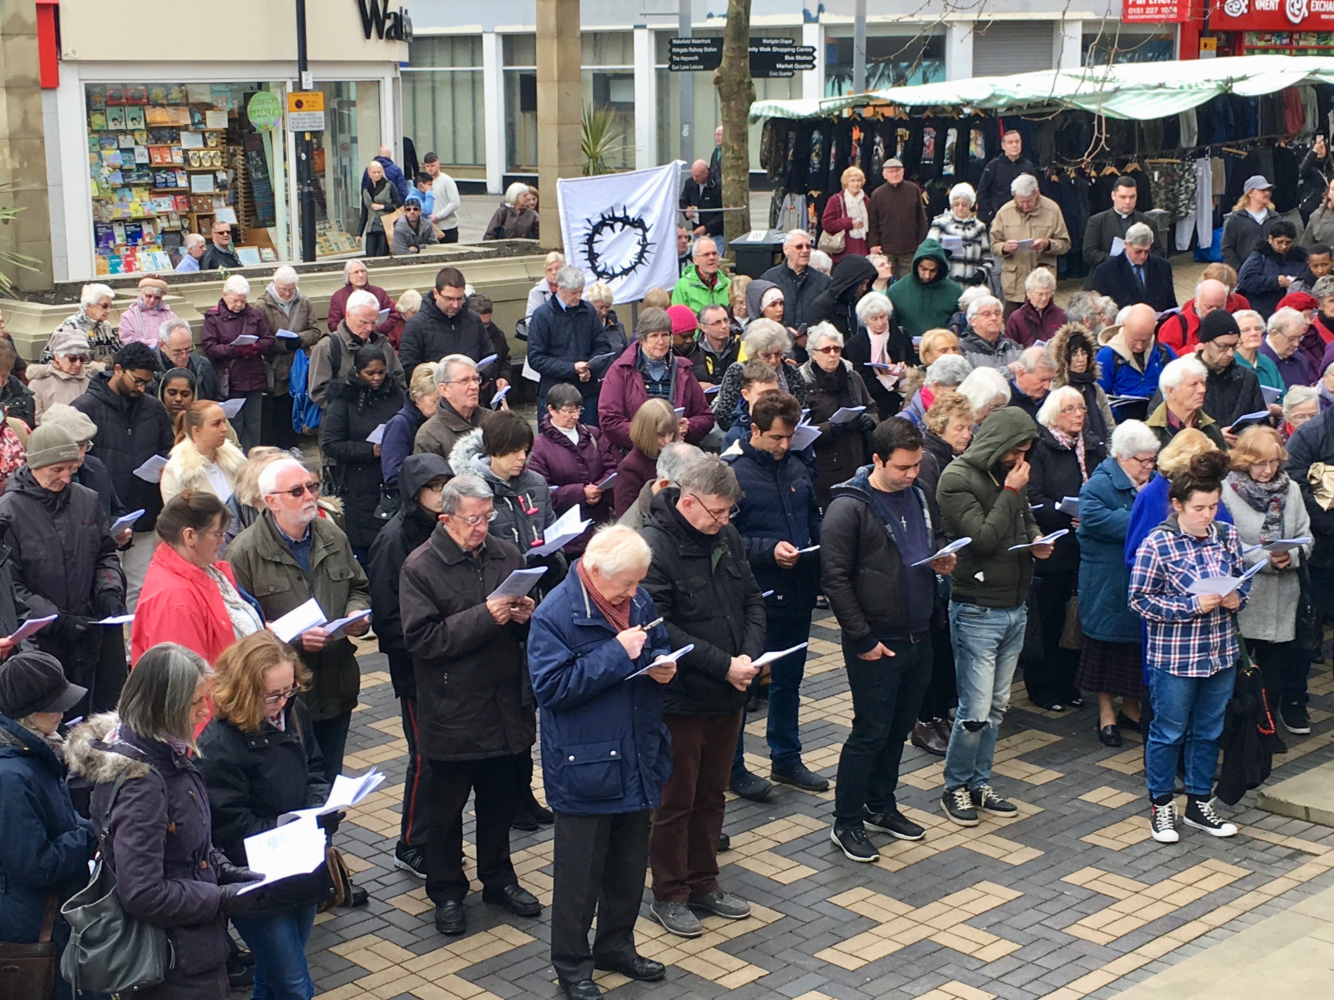
We would be very pleased to receive your news- and photos- to include here. The Administrator is happy to preach/speak on Unity to your church/ group….

